Countermeasures Laboratory Exercise

Block Objectives:

- Provide opportunity to perform CM as taught on various websites.
- Determine whether the CM performed appear to be typical physiology consistent with a non-deceptive examinee.
- Consider whether the performed CM activity leaves features that are atypical.

Procedures:

- Work in teams of two: One serves as the examiner, and the other as the examinee. After completing the exercise, reverse roles.

- One examinee will perform the CM suggested by Antipolygraph.org. The second examinee will perform the CM suggested by polygraph.com.

  - Phase 1 – Breathing CM: Practice each breathing CM. Read the instructions then practice following the instruction precisely.

  - Phase 2 – Physical CM: We have a worksheet with every physical CM that has been forwarded to the TASS Branch. We want you to try them all. If you so choose you can also stick a tack in your shoe. I don’t recommend that you do so.

  - Phase 3 – Mental CM: We have identified various confirmed Mental CM that have been forwarded to the TASS Branch. Try each one.

  - Phase 4 – Conduct a Security Polygraph Exam: Use the format for your particular agency. Use proper operations. Follow the instructions provided by either Antipolygraph.org or Polygraph.com.

    - Antipolygraph.org - pick one breathing instruction & either TB or mental CM. Perform the CM after answering the comparison question.

    - Polygraph.com - Use a different breathing instruction for each comparison with either an AS or a mental CM.

      - Chart 1 – Only breathing CM
      - Chart 2 – Only AS (very subtle)
      - Chart 3 – Only mental CM

    - If using Lafayette or Limestone, name your file or PF Folder: CM data (today’s six digit date) (your three initials). Example: CM data 041513dvw. If using Axciton, use “Tag 1” to identify your file as described above.

    - Run ACQT first (attack the key with a breathing & mental CM.

    - Conduct your security screening test performing CM as directed.

- Post-Mortem: Review the test data in the classroom and discuss findings.

PHASE ONE
Breathing CM

The following breathing CM is taken from The Lie Behind The Lie Detector at antipolygraph.org.

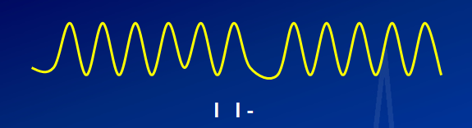

Apnea or Blocking (AB): Achieved by simply holding one’s breath for 4 or 5 seconds after breathing out (anything much longer may make your polygrapher suspicious)

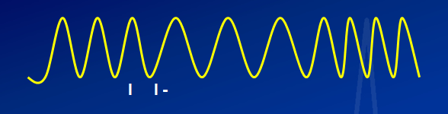

Change in Rate (CR): Produced by breathing more slowly for 5 to 15 seconds, ending before the asking of the next question

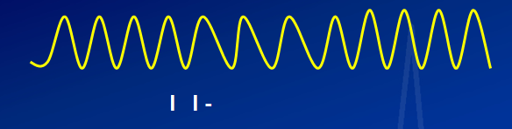

Change in Inhalation/Exhalation Ratio (IE): Exhale more slowly than inhaling for 5 to 15 seconds, ending before the asking of the next question.

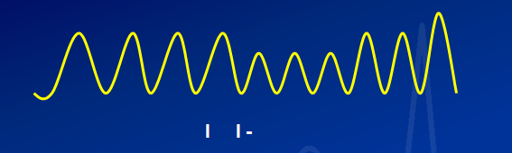

Suppression/Decrease in Amplitude (SD): Take several shallower breaths for 5 to 15 seconds and then return to one’s baseline pattern before the asking of the next question.

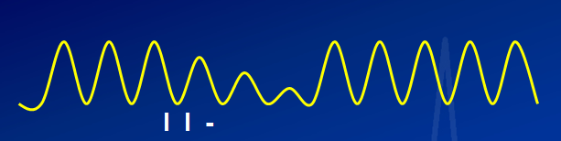

Progressively Decreasing in Amplitude (PD): Breathe shallower gradually for 5 to 15 seconds before returning to one’s baseline breathing pattern, ending before the asking of the next question.

The following breathing CMs is taken from polygraph.com:

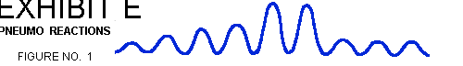

Progressive Increase in Amplitude (PI): (1) Inhale about 1/3 the normal amount of air, hold slightly, and exhale slowly, showing no jagged edges, (2) inhale again, this time inhaling about 2/3s the normal amount of air, exhale slowly, (3) inhale and exhale the normal amount of air, (4) inhale again, this time inhaling just a little more air than normal, and exhale slowly. Now take 2 deep breaths, and resume your normal breathing pattern.

Five Small Breaths (SB): After exhaling take 5 small breaths inhaling more air than you exhale until your last breath fills your lungs with slightly more than the normal amount of air, as if you are frightened and gasping for breath. Then take 2 deep breaths and resume normal breathing.

Apnea: Do not use this breathing CM because it is too obvious.

The Crown (TC): Inhale a normal amount of air and then take a series of 5 to 7 shallow breaths with your lungs partially full.

The worm (TW): Exhale and with lungs almost empty take 5 to 7 shallow breaths.

PHASE ONE
EXERCISE INSTRUCTION SHEET
Examiner’s Worksheet

- Chart Markings: Prepare a question list using the below annotations so the CMs will be properly marked on the chart collected.

Countermeasure comment Chart marking

Apnea…………………………………….now AB

Change rate……………………………….now CR

IE…………………………………………now IE

Suppressed/decrease……………………...now SD

Progressive decrease……………………...now PD

Progressive increase………………………now PI

5 small gasping breaths…………………...now SB

Inhale then 5 to 7 small breaths…………..now TC

Exhale then 5 to 7 small breaths………….now TW

- Record observations – Scrutinize your partner while he/she is doing the CM. Do not make the mistake of looking at the computer monitor! Make sure there is at least 20 seconds between questions. Examinee needs some time to recover.

- Get with your partner and discuss the test data – Discuss whether the test data looks typical or atypical.

- Look at the other channels (EDA and Cardiograph) – is there anything in either channel that appears abnormal. Describe what you see.

- Save the test data as described above: CM data breathing (today’s six digit date) your initials: Example: CM data breathing 041513dvw
PHASE TWO
Physical CM

- All of the CM identified below to be performed after the question is finished and should continue for 5 to 15 seconds.

Physical CM

- AS Anal Sphincter – slowly tighten anal muscle as if trying to stop a bowel movement then slowly loosen the muscle. Not too fast and not too tight.

- TP Toe Press – Slowly press the big toe to the floor as hard as you think you can get away with without being caught. Repeat the action stopping before the next question.

- TC Toe Curl – Curl toes up as hard as you can without moving.

- TB Tongue Bite – Bite the side of your tongue hard enough to cause slight pain.

- LB Lip Bite or Cheek Bite – Bite the inside of the lip or cheek hard enough to cause slight pain.

- TU Tongue Up – Push tongue hard against the roof of your mouth or against the back of your teeth.

- XE Cross Eyes – Cross your eyes

- EU Eyes Up – Looking up hard as if rolling your eyes to the back of your head.

- SC Stomach Crunch – Tighten stomach muscles for 5 to 15 seconds.

- PF Press fingers – Press fingers down slowly (non-EDA hand) then slowly let off the pressure.

- TT Tighten thigh muscles – Slowly tighten then slowly loosen.

- TJ Tighten jaw muscle – Slowly tighten and hold for 5 seconds then slowly loosen.

PHASE TWO
EXERCISE INSTRUCTION SHEET
Examiner Worksheet

- Chart Markings: Prepare a question list using the below annotations so the CMs will be properly marked on the chart collected

Countermeasure comment Chart marking

Anal Sphincter…………………………….now AS

Toe Press………………………………….now TP

Toe Curl..…………………………………now TC

Tongue Bite……….……………………...now TB

Lip Bite…………………………………...now LB

Tongue Up………..………………………now TU

Cross Eyes………………………………...now XE

Eyes Up……………………….…………..now EU

Stomach Crunch……………….………….now SC

Press Fingers………………………………now PF

Tighten Thigh Muscles……………………now TT

Tighten Jaw Muscles………………………now TJ

- Record observations – Scrutinize your partner while he/she is doing the CM. Do not make the mistake of looking at the computer monitor! Make sure there is at least 20 seconds between questions. Examinee needs some time to recover.

- Observe examinee and see if you can catch him or her performing the CM. Do not say anything to the examinee. We want you to get in the habit of watching the examinee rather than the computer screen and time bar.

- Get with your partner and discuss the test data – place notes on the test data as to why the test data appears atypical. See if you can write a description of the atypical physiology.

- Look at all channels (Pneumograph, EDA, and Cardiograph) – is there anything in any channel that appears atypical. Describe what you see.

- Save the test data as described above: CM data physical (today’s six digit date) your initials: Example: CM data physical 041513dvw

PHASE THREE
MENTAL COUNTERMEASURES

- All mental CM to be performed after the answer and should continue for 5 to 15 seconds.

- MA Mental Arithmetic – Pick a number above 600 and count backwards by 7s. If that appears too difficult, count backwards by 3s. Continue 5 to 15 seconds.

- EI Excitable Image – Pick a dangerous situation, sexual encounter, traffic accident, etc. Concentrate on that image for 5 to 15 seconds.

- SI Sad Image – Pick a sad image and concentrate on it for 5 to 15 seconds.

- SS Sing a song – Pick a song and sing it in your head for 5 to 15 seconds.

- RW Recite Words - poetry, Bible verse, Street names, various buffet foods in a Chinese restaurant – Recite it for 5 to 15 seconds.

- SC Scream in your head for 5 to 15 seconds.

- AT Angry Thought into your mind and concentrate on it for 5 to 15 seconds.

- MTB Mental Arithmetic and a Tongue Bite for 5 to 15 seconds

- MTP Mental Arithmetic and a Toe Press for 5 to 15 seconds

PHASE THREE
EXERCISE INSTRUCTION SHEET
Examiner Worksheet

- Chart Markings: Prepare a question list using the below annotations so the CMs will be properly marked on the chart collected

Countermeasure comment Chart marking

Mental Arithmetic.……………………….now MA

Excitable Image………………………….now EI

Sad Image..………………………………now SI

Sing Song……..….……………………...now SS

Recite Poetry or Bible Verse.…………...now RP

Scream in your head.……………………now SC

Angry Thought..………………………...now AT

Mental Arithmetic & Tongue Bite.……..now MTB

Mental Arithmetic & Toe Press..……….now MTP

- Record observations – Scrutinize examinee. Do not make the mistake of looking at the computer monitor! Make sure there is at least 20 seconds between questions. Examinee needs some time to recover. Annotate anything that appears atypical.

- Discuss the test data – place notes on the charts as to why the test data appears abnormal. See if you can write a description of the atypical physiology.

- Look at all channels (Pneumograph, EDA, and Cardiograph) – is there anything in any channel that appears Atypical? Describe what you see.

- Save the test data as described above: CM data mental (today’s six digit date) your initials: Example: CM data mental 041513dvw

PHASE FOUR
SECURITY POLYGRAPH EXAMINATION

- Use the polygraph format that is provided by your agency.

- Use proper operations (at least 20 seconds between questions.

- Lable the test Security the 6 digit date and your initials: (e.g., Security 041513dvw)

- Antipolygraph.org examinee pick one of the breathing instructions and either a TB or mental CM. Use at the key on the ACQT and at each comparison question. If conducting an R/I use at each Irrelevant question.

- Polygraph.com examinee:

  - Chart 1 – A different breathing CM for each comparison question
  - Chart 2 – A subtle anal sphincter at each comparison question. If you have placed a towel or other padding in the back of your pants consider using the AS with more force.
  - Chart 3 – Only use a mental CM

